CO3-ASSESSMENT TOOL -2
CSA-0603-DESIGN AND ANALYSIS OF ALGORITHMS
K Sravan Kumar- 192311210 Date:5-08-2026

TITLE
Web Server Log Analysis Using Sorting and Binary Search (Divide and Conquer Approach)

Description of the Real-World Problem
Web servers generate thousands or even millions of log entries every day. These logs contain important information such as IP addresses, timestamps, request methods, URLs, response codes, and response times. Searching for a particular log entry directly from an unsorted log file is slow and inefficient. Therefore, sorting the log records first and then applying Binary Search helps in retrieving required information quickly and efficiently.

Problem Statement
Design a system that efficiently processes a large web server log file by:
- Sorting the log records based on a selected field (Timestamp or IP Address).
- Searching for a specific log entry using Binary Search.
- Reducing search time for large datasets.
- Applying Divide and Conquer techniques to improve efficiency.
- Analyzing the overall time complexity.

Algorithm Used
Sorting Algorithm: Merge Sort
- Divide the log file into two halves.
- Recursively sort each half.
- Merge the sorted halves.
Searching Algorithm: Binary Search
- Compare the middle element with the target.
- If equal, return the result.
- If smaller, search the right half.
- Otherwise, search the left half.
Both algorithms follow the Divide and Conquer technique.

Justification for Choosing the Algorithm (Why This Algorithm?)
- Merge Sort guarantees O(n log n) time complexity.
- Efficient for very large datasets.
- Stable sorting algorithm.
- Binary Search provides O(log n) search time.
- Suitable for sorted log files.
- Combination significantly reduces processing time.

Complexity Analysis
Operation | Algorithm | Best Case | Average Case | Worst Case
Sorting | Merge Sort | O(n log n) | O(n log n) | O(n log n)
Searching | Binary Search | O(1) | O(log n) | O(log n)
Overall | Merge Sort + Binary Search | O(n log n) | O(n log n) | O(n log n)
Space Complexity
- Merge Sort: O(n)
- Binary Search: O(1) (Iterative)

Manual Execution (Step-by-Step Process)
Sample Log IDs
404
201
503
301
102
450
Step 1: Original Logs
404
201
503
301
102
450

Step 2: Divide
404 201 503
301 102 450

Step 3: Further Divide
404
201
503
301
102
450

Step 4: Merge in Sorted Order
201 404
201 404 503

102 301
102 301 450

Step 5: Final Sorted List
102
201
301
404
450
503

Step 6: Binary Search for 404
Initial List
102 201 301 404 450 503
Middle = 301
404 > 301
Search Right Half
Right Half
404 450 503
Middle = 450
404 < 450
Search Left Half
Remaining
404
Element Found.

Applications
- Web server log management
- Network traffic monitoring
- Cybersecurity analysis
- Cloud server monitoring
- Database indexing
- System performance analysis

Advantages
- Fast searching after sorting.
- Suitable for large datasets.
- Efficient Divide and Conquer approach.
- Predictable time complexity.
- Stable sorting with Merge Sort.
- Reduces overall processing time.

Limitations
- Merge Sort requires additional memory.
- Binary Search only works on sorted data.
- Initial sorting takes time.
- Not ideal for frequently changing datasets.
- Large log files require more storage.
- Merge Sort has recursive overhead.

Comparison with Other Algorithms

Algorithm | Time Complexity | Suitable for Large Logs | Stable | Divide & Conquer
Bubble Sort | O(n²) | No | Yes | No
Selection Sort | O(n²) | No | No | No
Insertion Sort | O(n²) | Moderate | Yes | No
Quick Sort | O(n log n) Average | Yes | No | Yes
Merge Sort | O(n log n) | Yes | Yes | Yes
Linear Search | O(n) | Slow | — | No
Binary Search | O(log n) | Very Fast | — | Yes

Program (Python)
def merge_sort(arr):
if len(arr) > 1:
mid = len(arr) // 2
left = arr[:mid]
right = arr[mid:]

merge_sort(left)
merge_sort(right)

i = j = k = 0

while i < len(left) and j < len(right):
if left[i] < right[j]:
arr[k] = left[i]
i += 1
else:
arr[k] = right[j]
j += 1
k += 1

while i < len(left):
arr[k] = left[i]
i += 1
k += 1

while j < len(right):
arr[k] = right[j]
j += 1
k += 1

def binary_search(arr, target):
low = 0
high = len(arr) - 1

while low <= high:
mid = (low + high) // 2

if arr[mid] == target:
return mid
elif arr[mid] < target:
low = mid + 1
else:
high = mid - 1

return -1

logs = [404, 201, 503, 301, 102, 450]

merge_sort(logs)

print("Sorted Logs:", logs)

target = 404
result = binary_search(logs, target)

if result != -1:
print("Log Found at Index:", result)
else:
print("Log Not Found")

Screenshot of the Program
Insert a screenshot of the above Python code from your IDE (VS Code, PyCharm, IDLE, or Jupyter Notebook).

Output Screenshot
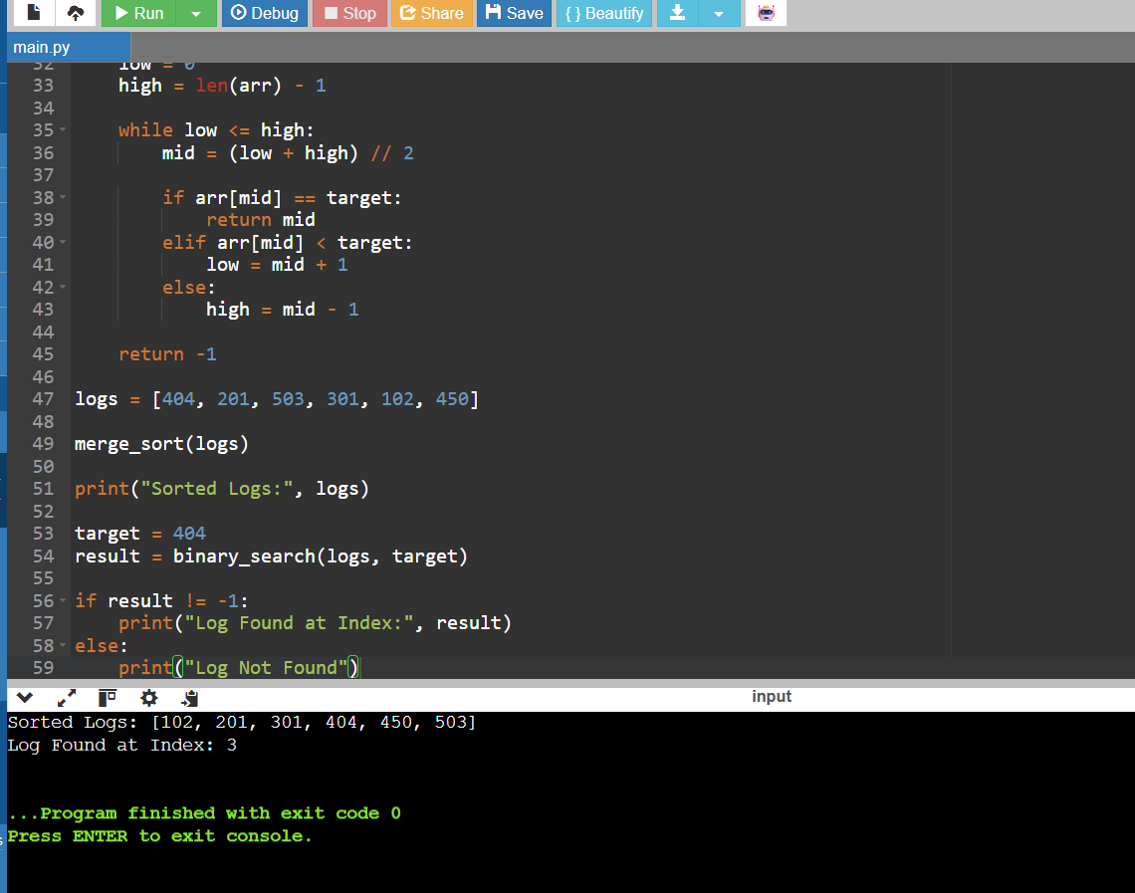

Conclusion
Sorting and Binary Search together provide an efficient solution for analyzing large web server log files. Merge Sort organizes log records in O(n log n) time, while Binary Search retrieves required log entries in O(log n) time. The Divide and Conquer approach improves scalability, reduces search time, and makes the system suitable for handling large volumes of server logs in real-world applications. This combination is widely used in log analysis, database indexing, and network monitoring systems due to its efficiency and reliability.

